Yoga and Meditation coastal retreat:

Trefacwn, St Davids, West Wales

Four day yoga retreat with Monica Voss –

June 1st to 4th 2023

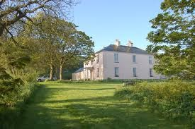

Trefacwn is a Grade 2 listed Georgian Mansion overlooking the Irish Sea on the beautiful and unspoiled North Pembrokeshire landscape of West Wales. It is set in four and a half acres of lawns and woodland, in a stunning location, with panoramic views over both the countryside and sea; from Strumble Head (six miles north) to St Davids Head (6 miles south). More information can be found at http://www.trefacwn.co.uk/

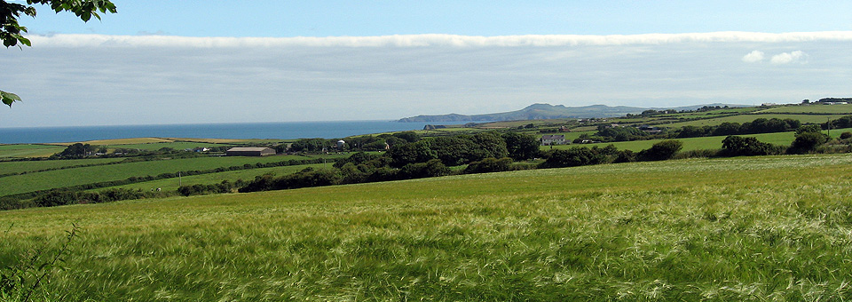

The weekend retreat at this beautiful tranquil coastal estate includes
- 3 nights accommodation,
- 4 days of yoga & meditation shared by Monica Voss,
- Accommodation: options include a range of accommodation in the mansion, some with sea views & en-suite bathroom,
- Sauna & invigorating freshwater lily-pad swimming pool,
- Organic meals (breakfast, lunch and dinner) and teas & snacks
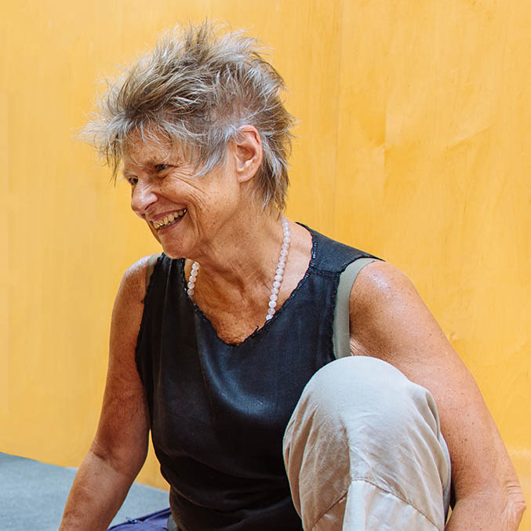
This retreat will offer yoga practice, relaxation, meditation and pranayama that will take place in the beautiful purpose-built roundhouse with underfloor heating. As well as the yoga, there will be plenty of space and time for personal reflection, writing, walking, socializing, resting and enjoying the peace and tranquility of both the estate and local area. You can participate in every session or take time out to relax or explore the beautiful countryside. Everyone, at any level of yoga, is welcome.

The group facilitator and yoga teacher will be Monica Voss.

Monica came to yoga with a background in drama and movement and has degrees in English Literature and Education. Monica studied with Vanda Scaravelli from 1986-1998. Moving into the poses using the rhythm of the breath and the support of the ground resonates deeply for her and she continues to draw inspiration from Vanda’s and Esther Myer’s teaching, from the natural world, from complementary modalities, from study, and from interaction and dialogue with students and colleagues.

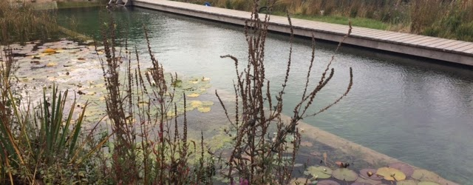

Accommodation
There is a twin and a king-size room available in the cottage on the estate and single and shared accommodation in the mansion available, including:
Twin
Double and
Kingsize
dormitory style triple room,
single (with a supplement)
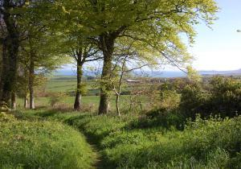

Prices range from £500 for triple dorm accommodation, £550 for twin rooms or for couples sharing in king- sized rooms inclusive of yoga. The price of single occupancy in a king-sized room ranges from £650 to £680. Partners may attend and pay exclusive of the yoga. There are also options for non-residential guests, and camping with your own tent.
A non-refundable £150 deposit will secure your space with the balance paid a month before the retreat. Payments may be made in instalments, by arrangement.

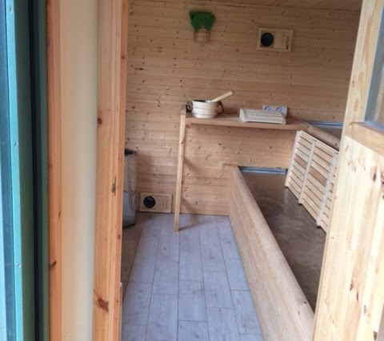

Contact
Di O’Reilly, d-or@hotmail.co.uk or Jo Bogacz, jo_bogacz@hotmail.com for more details and to book.
Alternatively, feel free to call Di at 07772593256, or Jo at 07966050826.

The Pembrokeshire Coast, Wales
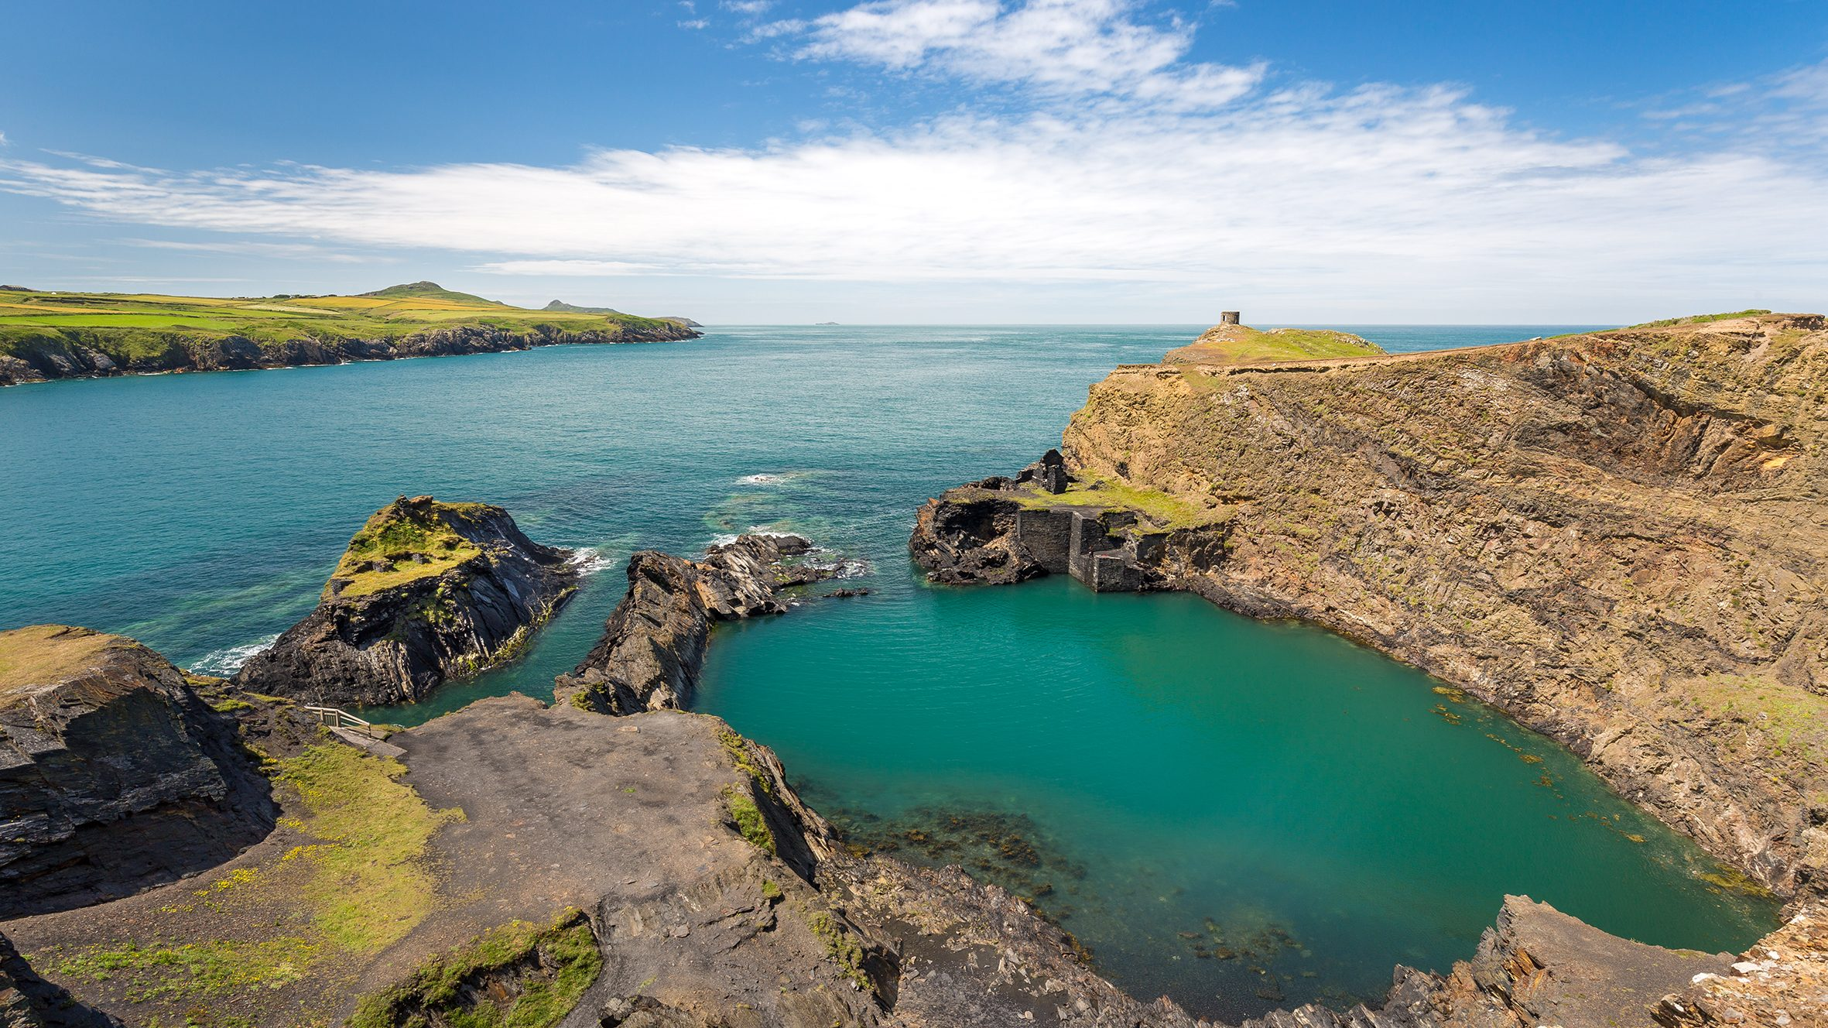
Things to do

The coastal path of Pembrokeshire has stunning shoreline, cliffs and beaches, including the Blue Lagoon above.
https://www.nationaltrust.org.uk/visit/wales/st-davids-peninsula/st-davids-head-coastal-walk

https://www.visitpembrokeshire.com/activities-adventure/walking?nm=&type[

https://www.nationaltrust.org.uk/visit/wales/abereiddi-to-abermawr

~

Hiring a boat is best to view the birds and sea life along the coast. (prebooking required)

Falcon Boats - Boat trips in Pembrokeshire, Wales

~

While those interested in Celtic and Christian history should certainly visit St. Davids (the UK’s smallest city) with their stunning Cathedral and generally Celtic vibe.

https://www.stdavidscathedral.org.uk/

https://www.visitpembrokeshire.com/explore-pembrokeshire/towns-and-villages/st-davids

~

Those interested in arts and crafts can visit the Melin Tregwy Woolen Mill or the artsy town of Solva which also has a woolen mill.

https://melintregwynt.co.uk/

https://www.nationaltrust.org.uk/visit/wales/solva-coast

Bird enthusiasts will want to visit Ramsey Island for their vast array of all things flying.

https://www.rspb.org.uk/reserves-and-events/reserves-a-z/ramsey-island/

~

Restaurants include
Really Wild Emporium
https://reallywildemporium.co.uk/

and

St David’s Kitchen
http://stdavidskitchen.co.uk/

~

Other useful links
https://www.tripadvisor.co.uk/Attractions-g552051-Activities- St_Davids_St_Davids_Peninsula_Pembrokeshire_Wales.html

https://www.visitwales.com/destinations/west-wales/pembrokeshire/St-Davids

~

And lastly, don’t forget, not far from Pembrokeshire, is the Hay-On-Wye Literary Festival, May 25-June 4, 2023.

https://www.hayfestival.com/wales/home

